DAENG ZHURIZAAZ BIN ZAHARI
CA25001
Intelligent Library Management System
Borrowing module
4.1 USE CASE DIAGRAM
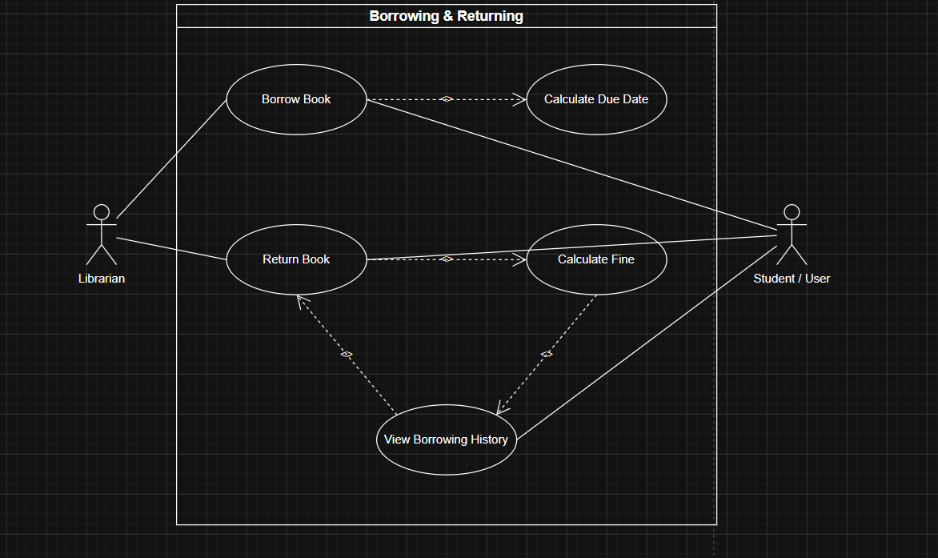

4.2 USE CASE DESCRIPTION
Use Case 1: Issue Books
Field | Description
Use Case Name | Borrow Book
Actors | Librarian, Student
Brief Description | Allows librarian to issue a book to a student and record due date.
Pre-condition | Student must have an active library account; book must be available.
Post-condition | Borrow record created with issue date and due date.
Basic Flow | 1. Librarian selects “Borrow Book”.  2. System displays search form for book ID and student ID.  3. Librarian enters details.  4. System checks availability.  5. System records transaction, calculates due date, and confirms success.
Alternate Flow | 4a: If book is already borrowed, system alerts “Book not available”.
Exception Flow | 3a: If student ID invalid, system shows “User not found”.
Constraints | Each book copy can only be borrowed by one student at a time.

Use Case 2: Return Book
Field | Description
Use Case Name | Return Book
Actors | Librarian, Student
Brief Description | Allows librarian to process book return and calculate fines if overdue.
Pre-condition | Borrow record exists for the student and book.
Post-condition | Book status updated to “Available”; fine recorded if applicable.
Basic Flow | 1. Librarian selects “Return Book”.  2. System retrieves borrow record.  3. System checks due date vs current date.  4. If overdue, system calculates fine.  5. System updates record and confirms success.
Alternate Flow | 2a: If no record found, system alerts “No borrowing record found”.
Exception Flow | 4a: If fine payment fails, system logs pending fine.
Constraints | Returned books must match borrow record.

Use Case 3: Calculate Due Date
Field | Description
Use Case Name | Calculate Due Date
Actors | System
Brief Description | System automatically calculates due date based on borrowing policy (e.g., 14 days).
Pre-condition | Borrow transaction initiated.
Post-condition | Due date stored in record.
Basic Flow | 1. System adds borrowing period to issue date.  2. Due date displayed and stored.
Constraints | Policy-defined borrowing period (e.g., 14 days).

Use Case 4: Calculate Fine
Field | Description
Use Case Name | Calculate Fine
Actors | System
Brief Description | System calculates fine if book returned after due date.
Pre-condition | Return transaction initiated.
Post-condition | Fine amount displayed and stored.
Basic Flow | 1. System compares return date with due date.  2. If overdue, fine = days overdue × rate.  3. Fine displayed and stored.
Constraints | Fine rate fixed (e.g., RM1/day).

Use Case 5: View Borrowing History
Field | Description
Use Case Name | View Borrowing History
Actors | Librarian, Student
Brief Description | Allows viewing of past borrowing and returning records.
Pre-condition | Student account exists.
Post-condition | History displayed.
Basic Flow | 1. Actor selects “View Borrowing History”.  2. System retrieves records. 3. System displays list of past transactions.
Constraints | Records are read-only.

4.3 Sequence Diagrams
Use Case 1: Issue Books

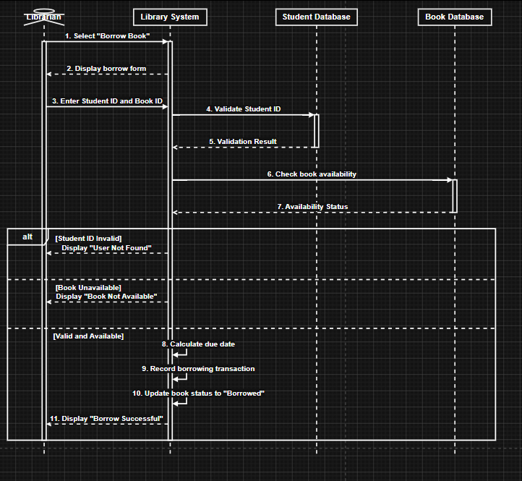

Use Case 2: Return Book
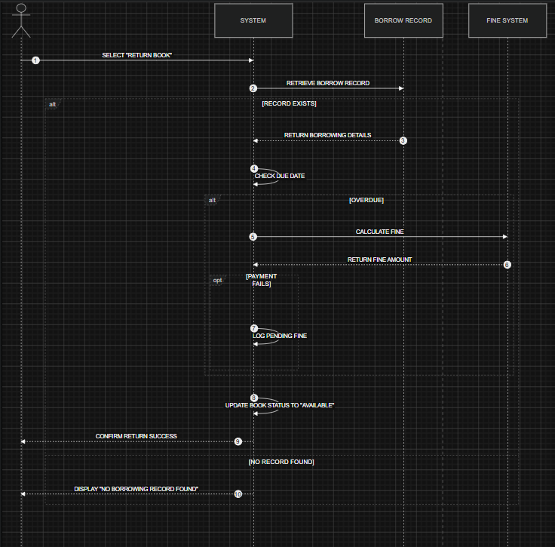

Use Case 3: Calculate Due Date
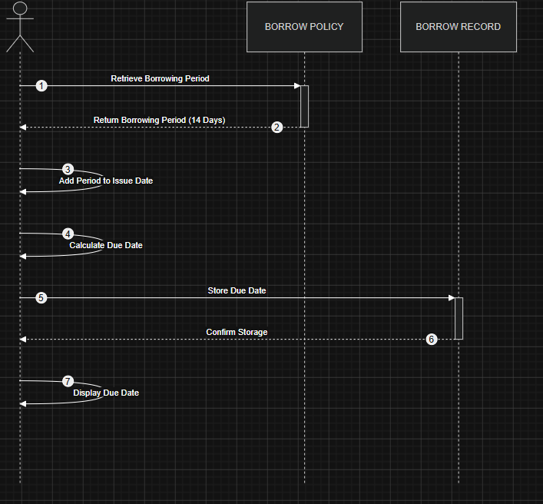

Use Case 4: Calculate Fine
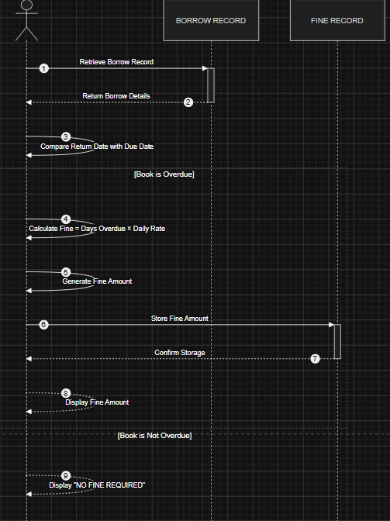

Use Case 5: View Borrowing History
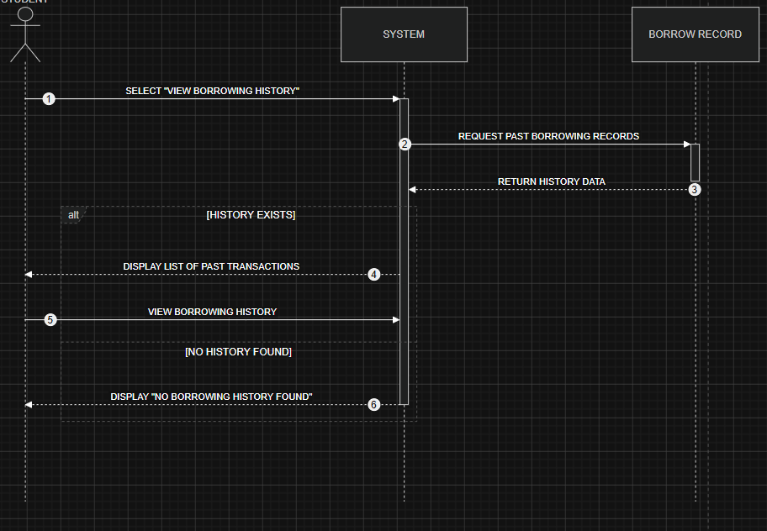

4.3 Class Diagram
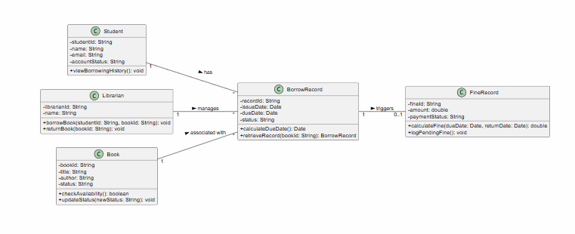
4.4 User Interface (UI) Design
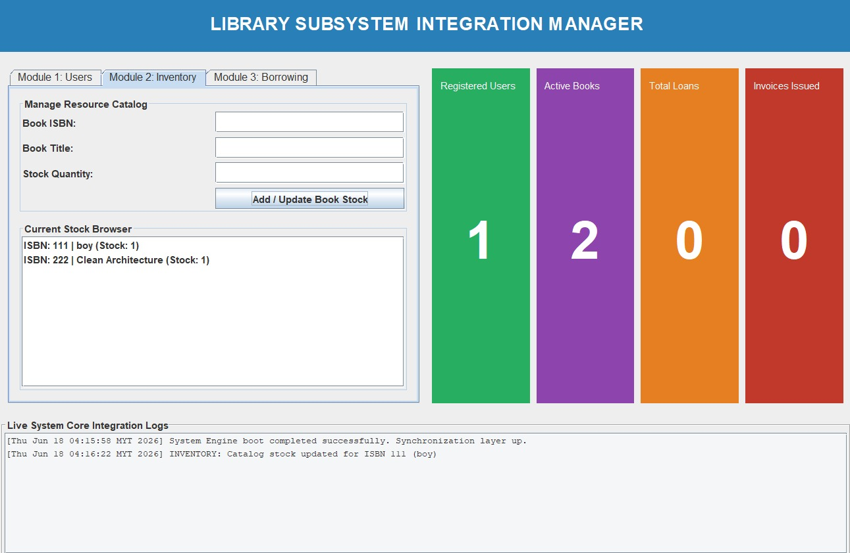
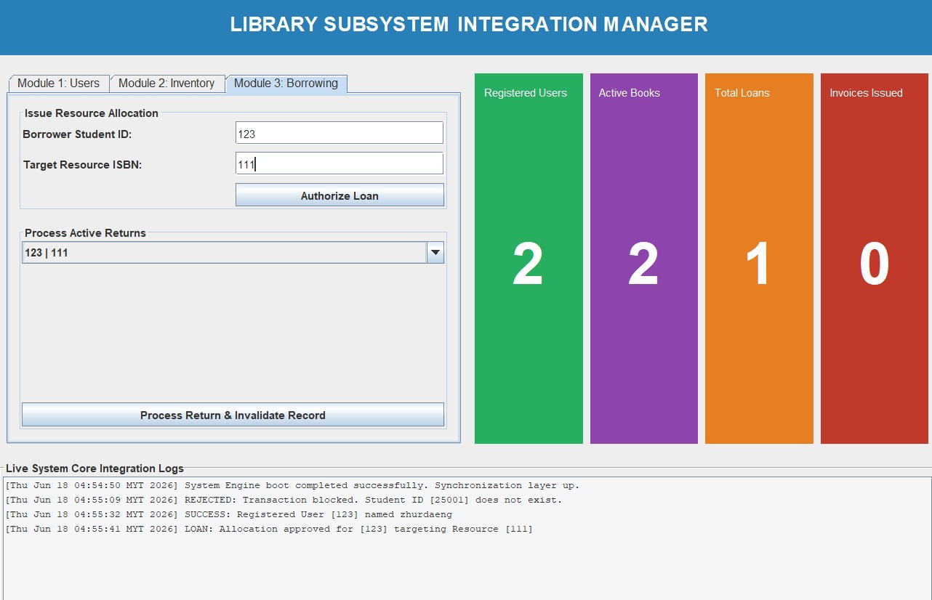

4.5 Program Implementation (Java)
The Billing & Pharmacy Subsystem (Module 4) is implemented using Java and strictly adheres to core Object-Oriented Programming (OOP) paradigms to ensure that financial tracking, insurance processing, and inventory modifications remain secure, modular, and scalable.
1. Encapsulation
Data hiding is strictly enforced to protect sensitive patient records, billing totals, and pharmaceutical asset states from unauthorized or accidental external modifications. In the system's core entities (such as Invoice.java and Medicine.java), all state variables are declared using the private access modifier. Other subsystem tiers can only read or safely interact with these attributes through secure, authorized constructor injections and public getter interfaces.
Code Evidence:
Java
// From Invoice.java & Medicine.java
package models;

public class Invoice {
private String invoiceId;
private String patientId;
private double consultationFee;
private double medicineFee;
private double insuranceOffset;

public Invoice(String invoiceId, String patientId, double consultationFee, double medicineFee) {
this.invoiceId = invoiceId;
this.patientId = patientId;
this.consultationFee = consultationFee;
this.medicineFee = medicineFee;
this.insuranceOffset = 0.0;
}

public String getInvoiceId() { return this.invoiceId; }
public String getPatientId() { return this.patientId; }

// Encapsulated calculation logic supporting Use Case 1 & 2
public double calculateNetTotal() {
return (this.consultationFee + this.medicineFee) - this.insuranceOffset;
}

public void applyInsurance(double offsetAmount) {
this.insuranceOffset = offsetAmount;
}
}
2. Inheritance
To prevent structural redundancy, reinforce architectural reuse, and standardize core entities across the entire enterprise system, inheritance is applied. An abstract base class, Person.java, handles standard profile records (such as system IDs and names) common across the enterprise. Subclasses like Patient.java utilize the extends keyword to inherit these shared fields automatically, allowing it to focus strictly on module-specific records like active prescription lists and billing history lines.
Code Evidence:
Java
// From Patient.java (Extending models.Person)
package models;

public class Patient extends Person {
private boolean hasValidConsultation;
private String activePrescriptionLog;

public Patient(String id, String name, boolean hasValidConsultation) {
super(id, name); // Safely invokes the abstract parent constructor
this.hasValidConsultation = hasValidConsultation;
this.activePrescriptionLog = "Pending";
}

public boolean checkConsultationStatus() {
return this.hasValidConsultation;
}
}
3. Polymorphism
The system relies on method overriding to leverage runtime polymorphism. This guarantees that independent financial items and logs can be handled uniformly by controller handlers, while executing behavior unique to their entity subtype. For instance, a generic base tracking method signature within the core structure is overwritten by specific domain modules using the @Override annotation to output precise audit strings for financial checkouts or inventory actions.
Code Evidence:
Java
// From Medicine.java (Overriding standard billing display methods)
package models;

public class Medicine {
private String medicineId;
private int stockQuantity;

public void updateStock(int modificationAmount) {
// Enforces Use Case 4 constraint: quantity cannot fall below zero
if (this.stockQuantity + modificationAmount >= 0) {
this.stockQuantity += modificationAmount;
}
}

@Override
public String toString() {
return "Medicine ID: " + this.medicineId + " | Stock Level: " + this.stockQuantity;
}
}
4. Proper Class Structure
The software architecture is split into cleanly decoupled packages, matching professional multi-tier enterprise design and isolating operations seamlessly across developers:
- models package: Holds standalone state data entities (Person, Patient, Invoice, Medicine) enforcing encapsulation boundaries while executing zero controller business choices.
- modules package: Contains BillingPharmacyModule.java, implementing the primary algorithmic business tier responsible for executing calculations, matching patient profiles, and modifying assets.
- storage package: Hosts HospitalDataStore.java, running a thread-safe Singleton pattern to share records securely across the application without risk of collision or loss.
- main package: Oversees the graphical dashboard layout environment (BillingPharmacyFrame.java), ensuring structural UI text inputs remain entirely separate from backend transactional storage code.

